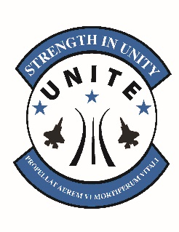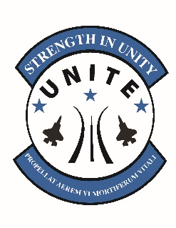

**UNITE PROGRAM**

**POC: Warren Baker**

Community Cohesion Coordinator (C3)

Warren.baker.4@us.af.mil

DP: 632-2390

***2024 SNAPSHOT- AVIANO***

***Total Funded Units: 76***

***Total Assigned Personnel: 5738***

* *Active Duty, Reservists, Civilians (NAF/APF/LNs), GSUs & Detachments included*

***CY24 Food Funding Allocation: $28,690.00***

***CY24 Activity Funding Allocation: $77,463.00***

***UNITE Program***

* Designed by AF Services Center to meet one of CSAF’s Focus Areas - “Revitalizing Squadrons”
* Primary focus is on the UNIT instead of the individual
* Equips SQ/CCs with **funding** to execute programs that benefit their unit and facilitate cohesion
* Events can be personalized to meet the needs and interest of units and ensure max participation
* Funded unit members include Active Duty, Reservists, Civilians (NAF/APF/LNs) *Note* Squadron Commanders can authorize spouses and dependents to participate in the allocated per person amount. The dollar figures will continue to be based on unit official manpower totals and will not increase with the inclusion of dependents.
* GSU’s and Detachments are supported with Unite funds
* Component of Recharge for Resiliency (R4R) – capstone for resiliency programming across the AF
* SQ/CC will designate a POC to work with Community Cohesion Coordinator(C3) to develop events
* Events must be **recreational** and **cohesive** to utilize funds

***Nonappropriated Funds (NAF)***

* $5.00 per person
* Used for the purchase of food and beverages in conjunction with a Unite event (no alcohol)

***Appropriated Funds (APF)***

* $13.50 per person (funding allocations may change annually)
* Designated to offset participation costs for unit cohesion/recreational activity

***Unauthorized Usage of Funds***

* Unite funds **cannot** be used for:
  + - Events that do not promote cohesion
    - Holiday parties/EOY events/Balls/Banquets/Dining In/Squadron Trainings
    - Lodging/equipment purchases/prizes/contractors

***Program Examples***

* *FSS Sponsored: Cosmic Bowling/ODR Paintball/Equipment Rentals/Art Courses/Custom Packages*
* *Unit Developed: Squadron Olympics/Cooking Competition/Video Game Competition/Nerf Wars*
* *Off Base: Escape Room/Go Karting/Ropes Course/Rock Climbing/ Battle Archery/Paintball*
* *Virtual: Virtual Fitness Classes/Custom Virtual Trivia Package/Teambuilding.com*
* *Movie theater is now an authorized use of UNITE funds*
* *Water/amusement parks, movies. Djs, Wing/Group events are now allowed*
* *Unite funds can be transferred by the owning Commander/Civilian leader to other squadron at the same location*
* *Renting a NAF vehicle/driver is allowed for transportation to an approved event*