426 ABS
STAVANGER
- NORWAY

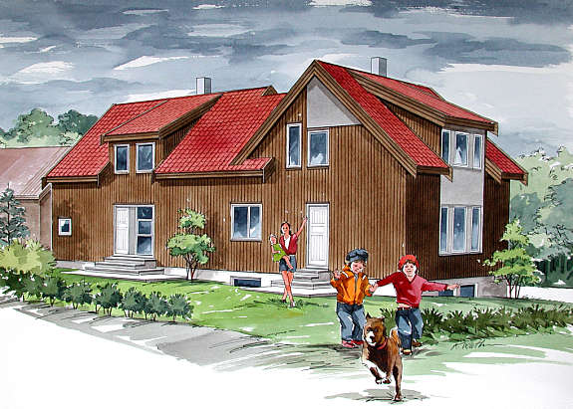
HOUSING
BROCHURE

7/31/2026



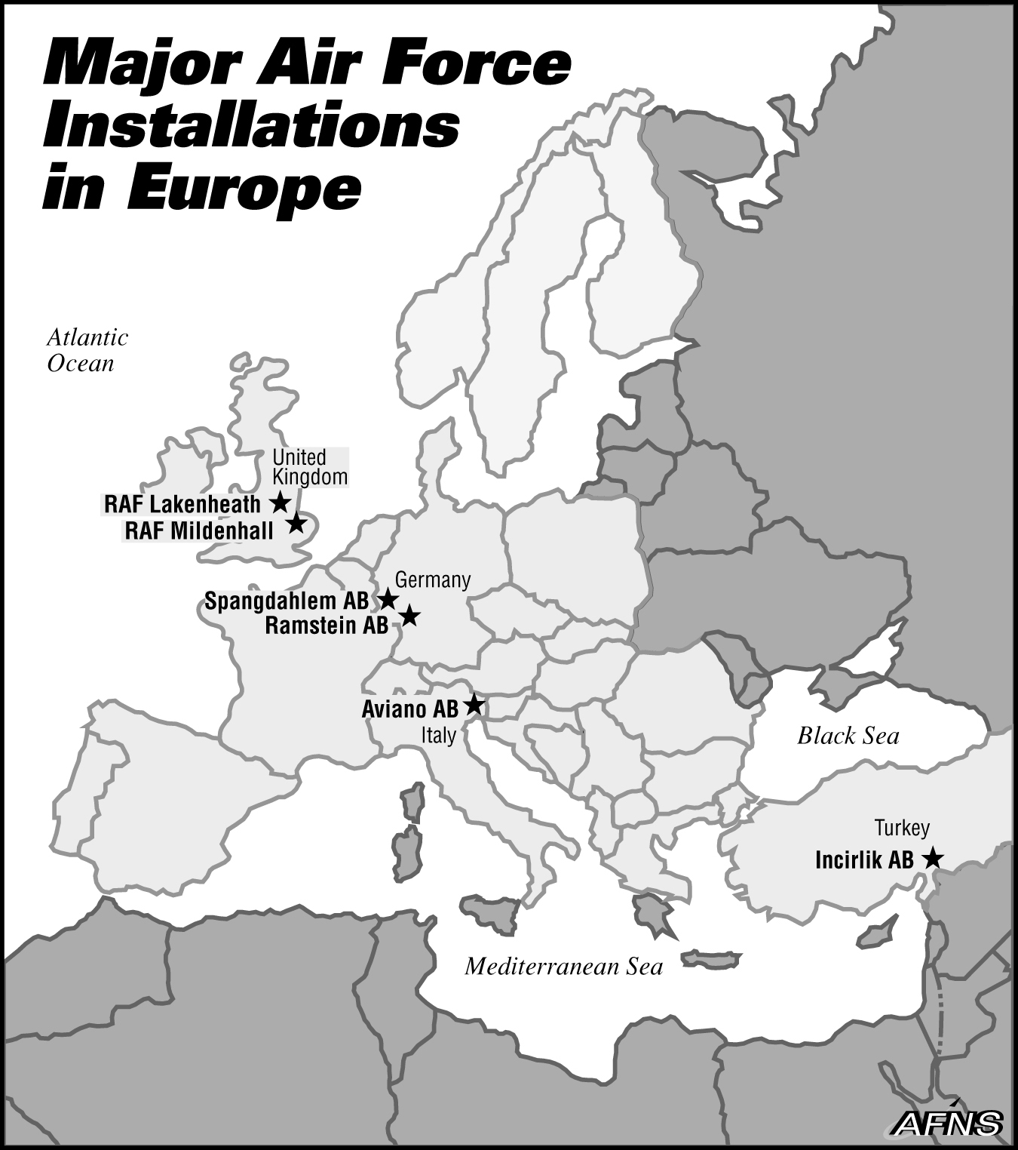
Stavanger
Norway

TABLE OF CONTENTS
Page
Welcome form the Housing Office 4
Your New Duty Station 4
Off Base Housing 4
About Norwegian Houses 4
Differences? 4
Funds Processing 5
TLA/OHA and MIHA 5
House Hunting List 9
TLA Extension Request 11
Looking for Your New Home 17
Housing In-Processing 18
Realtor Information Sheet 19
Tender Form 23
Appliances 24
Utilities 24
Heating and Lighting 24
Cable TV and AFN Satellite Dish 24
Telephone and Internet Connections 24
Useful Information 26
Radon In Your Rented Home 27
Local Bus Information 28
ISS School Bus 28
Road Taxes in Northern Jæren 28
Found Your New Home? 30
Before Signing the Contract 30
After Signing the Contract 30
Moving in 31
Housecleaning 31
Trash Pick up 31
Loaner Kits Request 33
Size of Loaner Appliances 34
Loaner Kit Extension 35
Landlord (Agent) Tenant Statement 37
Appliances and Satellite Dish Statement 39
Care of Government Appliances 41
Care and Maintenance of Furniture 42
Phone Request Telenor 43
Security Deposit 45
Useful Websites 49
Local Newspaper 49
Local Community Sites 49
Maintenance 51
General Maintenance 51
Important Check Points 52
Commonly Terms On Property Websites 53
Receiving Receipt for Housing Package 55

Welcome from the 426th ABS Housing Office
Welcome to Stavanger, Norway. One of the first stops for all new arrivals should be the 426th ABS Housing Office (CEH) located in the Intl. Support Building room 105, Phone 5195-0577. When you in-process thru CEH, we require one set of your orders. You will be briefed on in-processing and given a current listing of available houses in the area. While in TLA (Temporary Lodging Allowance) status, you should visit these listings and inform CEH of any listing no longer available also stating your reasons for any ‘turn-downs’.

Your New Duty Station

Off Base Housing
All members assigned to Stavanger, Norway, reside off base in civilian quarters. So the choice of a home is yours! When you in-process you will be informed of what allowance the finance office entitles you to. You could find a house located next to a fjord or with a view over the ocean, next to a park, downtown, or choose from a farmhouse to a modern day apartment, a house lying totally by itself or a duplex. The average cost of renting a house will be between NKr 17000-28000 ($2,900 – $4,800). CEH will set up one-by-one appointments with realtors in Stavanger. They will pick you up at the hotel and take you and your family out for house hunting in the local area. If you set up appointment with private landlord, you need to arrange transportation by yourself, ask your sponsor for assistance.

About Norwegian Houses
All Norwegian houses are very individual, unless you rent a town house/duplex or apartment. Nearly all houses are wooden, it is very rare to find a brick house; most have three levels (basement, main level and loft level) and as the houses are wooden, they will be painted in a variety of colors.

A lot of Norwegian houses have basement apartments, and rent these out as a separate unit - it should state on the house listings if the rental price is for the whole house or not. Most houses have good-sized yards and decks. The Norwegians take great pride in their yards, with lots of shrubs, bushes, fruit trees, and fruit bushes. While staying here, unless you have a private agreement with your landlord, you will be responsible for the upkeep of the yard. The property owner should provide you with the necessary gardening tools, lawn mower etc., if he wishes you to upkeep the yard. This should be written in your rental agreement.

Differences?
Most Norwegian houses are very large, the average being 180-220 Sq. Meters (1937-2368 Square Feet) and they concentrate on the ‘living area’ rather than sleeping areas. That is to say you will find the bedrooms are a lot smaller than in American homes - there usually is just enough space for a double bed and a closet and maybe a chest of drawers. Below is a conversion chart to help you estimate the size of your new home.

Square meter to square feet, 1 square meter = 10.76391 square feet
Square m. | square feet | Square m. | Square feet | Square m. | Square feet
20 | 215.28 | 120 | 1291.67 | 220 | 2368.06
50 | 538.20 | 150 | 1614.59 | 250 | 2690.98
80 | 861.11 | 180 | 1937.50 | 280 | 3013.89
100 | 1076.39 | 200 | 2152.78 | 300 | 3229.17

Most houses will have two bathrooms, and you will often find the guest toilet is separate to the second bathroom. Some houses will have bathtubs and others showers or both; it is also usual to have a heated floor in the main bathroom. Some houses will have an eating area in the kitchen, or a separate dining area in the living room with a wood- burning stove as the focal point.

Stairwells are narrower than in American homes, and nearly all floors in Norwegian houses are bare, natural wood. Many have floor heating installed. Wall-to-wall carpeting can be found but mainly only in bedrooms. If you find the bare wood floors cold you can always buy area rugs, which are abundantly available on the economy.

Closet space is limited; some houses do have built-in closets and some houses have free standing closets.

Kitchens will normally have: stoves, dishwashers, and refrigerator/freezers. Washers, dryers and chest freezers will normally be located either in the basement or a side pantry room. The HRO has most appliances available for long-term use during your tour if the landlord does not provide such items.

Funds Processing

MIHA
This is a one time payment (Move-in Housing Allowance) from which you should purchase items to complete your home i.e., rugs, lamps, and drapes. This should also help off-set the cost of telephone connection and/or cable TV.

TLA/OHA
Please come in to CEH as soon as possible so we can start a file for you. I will need 3 copies of your orders and a receipt from the hotel for every TLA claim you process. After 10 days I can process your 1st TLA claim (future claims after every 10 day interval). Please check through the TLA form to ensure it has the correct information and sign it. Wrong information on the TLA form can affect your payments.
Inbound TLA is limited to 30-days and will not normally be extended.
If government-controlled quarters are not available, service members must maintain a documented search for permanent housing. Within the first 10 days, the service member should view a minimum of two houses. During the subsequent 10-day increments, the service member should view at least additional five listings. If permanent housing has not been secured, necessitating a third 10-day increment, the service member must meet with a Housing Management Specialist or Housing Manager to justify additional TLA claims.
When circumstances beyond the members’ control require a TLA extension beyond 30 days, the service member will be required to submit a written request for extension. Under normal circumstances, TLA extension will not be allowed when referral listings are available within service member’s bedroom entitlement, Overseas Housing allowance (OHA) ceiling, and commuting distance as determined by the Housing Manager. Personal preference issues such as pets, furniture limitation, school district etc. are not justification for an extension beyond 30 days. If for any reason you need to extend the 30 days, approval from the 426 ABS Commander and Housing Officer with justification for
the extension will be required.

House Hunting List
Within the first 10 days, the service member should view a minimum of two houses. During the subsequent 10-day increments, the service member should view at least additional five listings. If permanent housing has not been secured, necessitating a third 10-day increment, the service member must meet with a Housing Management Specialist or Housing Manager to justify additional TLA claims.
Date | Ref. | Appointment  Realtors name | What you like or not like | Requested rent | Reason for not taking this house/apartment

Have to be turned in to 426 ABS Housing offices for every 10 days when you have a TLA claim

Member’s name: _______________________________________________________

Arrival Date: _________________________________________________________

TLA EXTENSION REQUEST

NAME: SSN#: #DEPS: ______________

ARR DATE: NEW ORG:

PHONE#:___________________________ ORDER#:__________________________________________

HOTEL:

TLA PERIOD: EXTENSION PERIOD REQUESTED:__________________

JUSTIFICATION: Personal preference issues such as pets, furniture limitation, school district etc. are not justification for an extension beyond 30 days. Under normal circumstances, TLA extension will not be allowed when referral listings are available within service member’s bedroom entitlement, Overseas Housing allowance (OHA) ceiling, and commuting distance as determined by the Housing Manager.

LEAVE
#LEAVE DAYS AUTHORIZED: #LEAVE DAYS APPROVED

“ I CERTIFY THIS INFORMATION IS TRUE AND CORRECT.”
I have viewed within the first 10 days, a minimum of two houses. Yes/No

I have viewed at least additional five listings during the subsequent 10-day increments. Yes/No

I have not secured permanent housing necessitating a third 10-day increment,
and I have met with Housing Management Assistant or Housing Manager to
justify additional TLA claims. Yes/No

I have provided a copy of House hunting list together with all TLA claims. Yes/No

MEMBER’S SIGNATURE:_______________________________________________ DATE:__________

1ST IND HOUSING REFERRAL OFFICE
RECOMMEND APPROVAL/DISAPPROVAL

HRO SIGNATURE:_______________________________________DATE:__________

2ND IND 426 ABS/CC
“ I CERTIFY TEMPORARY GOVERNMENT ACCOMMODATIONS WILL NOT BE AVAILABLE DURING THE REQUESTED PERIOD.”
APPROVE/DISAPPROVE

CC SIGNATURE:_________________________________________DATE:__________

TEMPORARY LODGING ALLOWANCE (TLA) FACT SHEET
The purpose of this fact sheet is to educate our incoming and outgoing personnel on how the PCS entitlement--TLA--is paid. Per the JFTR, U9150, paragraph A, TLA is provided to partially reimburse a member for the more than normal expenses incurred while occupying temporary lodging (lodging and meals). Please keep in mind that although the TDY Per Diem rates are used to calculate your daily TLA, the rules are different for TDY and PCS entitlements and should not be applied to one another.
Our primary goal is to give each member an estimated amount that will be paid for their TLA payment so you can budget accordingly during your stay in temporary lodging. The examples below are based on current data at the time of publication. Based on the JFTR computation (U9185, paragraph E), a member gets a percentage of the Lodging and M&IE rate based on their number of dependents. These percentages are used to calculate the member's daily TLA amount. The availability of kitchen facilities in the room also has a direct impact on the TLA amount. If you require a complete breakdown of your individual TLA computation, please contact your local FM office; otherwise use the estimates below as a guideline.

Negotiated Hotel Cost Kroner Amt
Single Room (w/o kitchen) 910 NOK - VAT=NOK 816.91 per Night
Apartment (with kitchen) or Double Room 1250 NOK - VAT=NOK 1115.24 per Night
(150 NOK added for each person if over 3 in apartment)

Ch 10: Housing Allowances
Part A: General Information
U10000-U10032
Change 280 U10A-11
04/01/10
http://www.defensetravel.dod.mil/site/ohaCalc.cfm

U10020 OHA - GENERAL
NOTES:
1. The OHA program is designed to help offset housing expenses for a member and/or dependent at the assigned overseas location. The reported housing must be the actual residence that the member occupies and from which the member commutes to and from work on a daily basis. If a member is assigned on an unaccompanied tour or has a Secretarial waiver and is authorized OHA for a dependent who lives separately, the reported housing must be the actual residence that the member’s dependent occupies.

2. OHA is not intended, and must not be allowed to be used, for the personal enrichment of a member by including costs incurred for procuring/adapting a residence to accommodate renters or for vacation purposes.

3. OHA is intended to assist in paying for private sector leased/owned housing for a member and/or a member’s dependent.

4. Disciplinary action addressed in par. U1055 applies when housing allowances are used for other than the purpose intended.

U.S. Department of State Foreign Affairs Manual Volume 15―Overseas Buildings Operations

15 FAM 237 DETERMINING RESIDENTIAL SPACE AUTHORIZATIONS
(CT:OBO-19; 10-27-2010) (Uniform State/USAID/Commerce/Agriculture/DIA)
a. An employee’s maximum residential space authorization is based on position rank and family size, adjusted for locality factors. The application of these factors in special circumstances is explained in 15 FAM 264. The maximum space authorizations for residences are defined in 15 FAM Exhibit 237(A) and 15 FAM Exhibit 237(B); waiver provisions are found in 15 FAM 312.8 and 15 FAM 322.
b. The space standards established by this subchapter are the maximum allowable and should not be construed as entitlements or goals to be sought for U.S. Government employees abroad. These regulations are not intended to preclude agencies from adopting smaller space standards for certain categories of personnel in keeping with the nature of their roles in the U.S. Government’s conduct of foreign relations.

15 FAM 238 COMPUTING SPACE
(CT:OBO-19; 10-27-2010) (Uniform State/USAID/Commerce/Agriculture/DIA)
Residential space standards are based on usable living space. See 15 FAM Exhibit 238(A), 15 FAM Exhibit 238(B), and 15 FAM Exhibit 238(C) for details on computing functional and residential net and gross space. If measurements are done in feet, posts should convert and maintain these in metric scale as Federal regulations require.

15 FAM EXHIBIT 237(A) SPACE STANDARDS CHARTS SHOWN IN SQUARE FEET AND (SQUARE METERS)
(CT:OBO-7; 04-26-2006)
LOCALITY 1
Rank (measurement) | Number of Occupants
 | 1-2 | 3-4 | 5-6 | 7+
Executive(sq ft) | 1700 | 2146 | 2465 | 2592
(sq meter) | 158 | 199 | 229 | 240
Middle (sq ft) | 1296 | 1870 | 2188 | 2316
(sq meter) | 120 | 174 | 203 | 215
Standard (sq ft) | 1168 | 1700 | 1976 | 2103
(sq meter) | 109 | 158 | 184 | 195

15 FAM 230 Page 17 of 19 15 FAM EXHIBIT 238(B) MEASURING SPACE FOR RESIDENTIAL PROPERTIES
(CT:OBO-19; 10-27-2010)
Net space includes all usable living space on all floors, measured from wall-to-wall within each room: reception rooms, ballrooms, living rooms, dining rooms, bedrooms, kitchens (from wall-to-wall, including cupboard/ counter space), breakfast and eating areas, pantries (unless exclusively storage space), libraries, dens/studies, family and recreation rooms, powder rooms, bathrooms, dressing rooms, enclosed patios/terraces/balconies (if heated/air-conditioned and usable year-round).
Net space excludes open balconies, garages, halls, foyers, stairwells, elevator and chimney shafts, dumbwaiters, domestic staff quarters (only areas specifically designed as such), utility shafts/closets, laundry or household appliance rooms, built-in closets (or space occupied by wardrobes), furnace/fuel rooms, and storage areas. If live-in help occupies space that would otherwise be used by the occupant as living space, this space does not qualify as domestic staff quarters and must be included in the net total. Do not measure exterior walls and thickness of interior partitions when measuring usable space. (If portions of residential space must be used for official storage, post should request a waiver from the Bureau of Overseas Buildings Operations (OBO) to deduct it from net area.)
Gross space includes all areas on all floors within the normal outside surface of the exterior walls, hallways and foyers, attics and basements, finished or unfinished, if a person can walk upright in them and they are easily accessible (exclude crawl spaces in attics and basements), stairwells, elevator and chimney shafts, and dumbwaiters or similar installations. Measure these areas as if the actual floors were in existence on each level and there were no stairway, elevator, or other shaft. Gross space includes mechanical equipment rooms, garages, and servants’ quarters that are incorporated in the main structure and part of the residence.
Gross space excludes separate outbuildings (garages, sheds, and domestic staff quarters). If they are significant in size or function, report them as ancillary structures. Gross space also excludes open courtyards or walkways that lead from one building or section of a building to another, loading platforms, outside porches, outside stairs, terraces, parking lots and open, but covered, outside parking.
NOTE: Gross area must be greater than net. All net space is automatically included in gross. Areas not included in gross should not be included in net area.

Looking for Your New Home

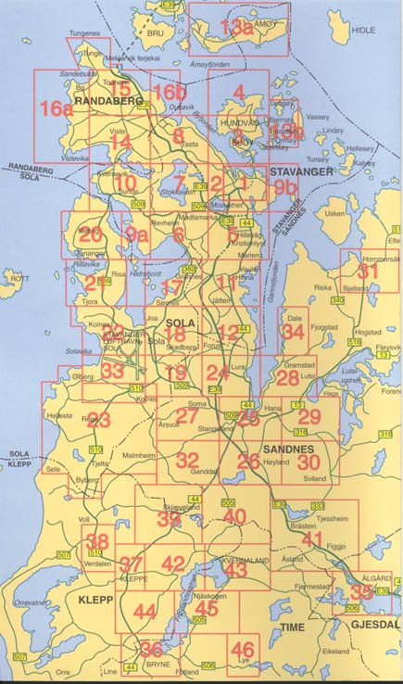
Joint Warfare Center and the 426th ABS is in Square 11 (Eikesetveien 29, 4032 Stavanger)
International School of Stavanger is in Square 6 (Treskeveien 3, 4043 Hafrsfjord)
The Children’s House is in Square 17 (Kornbergveien 23, 4050 Sola)

 | Housing In-Processing | YES | NO
1 | Did you get a housing brochure, “Renting a Home in Norway” pamphlet, TLA/OHA and realtor information during your in-brief?
2 | Did you get information about Finn.no of available properties and a scheduled appointment with the realtors? Beware! Oral agreements are legally binding here.
3 | Did you get a map (if available) of the local area?  Did you turn back the map book after you found a house?
4 | Utilities - Electric Lyse 51908090  Did you read the electric meter and notify the energy company with your name, address, phone number and date of birth.
5 | Utilities - Telephone Telenor 05000 Lyse 51908090  It is your responsibility to apply for a phone connection. CEH can assist you with the paperwork; if you have a D-number when you apply the process is easier.
6 | Cable TV – Satellite Dish GET 02123, canaldigital 06090, viasat 81522022  There are many providers on the market. CEH can assist you to find what is available in the area where your house/apartment is located.
7 | Internet – ADSL 24/7 Telenor 05000 nato.bestilling@online.no , Lyse 51908090,GET 02123  There are many providers on the market. CEH can assist you to find what is available in the area where your house/apartment is located.
8 | Toll Ring Nord-Jæren Bompengeselskap 815 11 090  If you require a brick for the toll ring, Esso gas stations have application forms.
9 | Loaner Furniture 51950577  Have you arranged for delivery/pick-up of loaner furniture/and or appliances with the housing office? Thursday 8 -12 am appointments are preferred.  Member should be available to sign for any deliveries.
10 | Bank Accounts Sr-bank 02002, DNB 04800, Sandnes Spare bank 51676793  Ask your sponsor to assist you to set up a bank account. Your Norwegian bills and rent can be paid online. Some banks have web pages in English..ask them!
11 | Inspection of House 51950577  Do you require an inspection of your house with housing office?  The realtor will do an inspection on the day you move in.
12 | USAFE Form 333  Has this been completed and returned to housing within 10 days after you moved in?  The form needs to be signed by you and the landlord or his representative.  When taking over the house you have 14 days to notify your landlord about any damages/problems.
13 | TLA Claim  Turn in your hotel receipt and 2 copies of your orders every 10 days for your TLA Claim.  Members must hand in hotel bills personally and sign all TLA Claims.
14 | OHA Claim  Return a signed copy of your lease together with 2 copies of your orders for your OHA Claim. If your landlord requires a security deposit and you need assistance contact FMF for assistance. Members must hand in the Lease personally and sign the OHA Claim.
15 | Waste/garbage.  If you have a lot of garbage after you move in you can dispose of it at Forus Recycling Station. Cost runs 50-200 NOK based on how much you have. Open: Mo-Tu-We-Fr 0900-1600, Th 0900-1900, Sa 0800-1500.  Many shopping centers/stores have a small unmanned recycling stations. CEH can inform you of the nearest station to where you live.
DISCLAIMER: Information provided about local vendors is for information purposes only. The 426th ABS Housing office does not recommend or endorse any of the vendors listed.

Realtor Information Sheet:
NOTE: Due to the high activity in this area, the realtors are very busy. Try to limit your viewing to properties within your rental cap or up to how much you are willing to pay. Please do not spend time on viewing properties you know will be to expensive for your budget.

EM-1 Boligleie Utleiemegleren
http://www.boligutleie-stavanger.no http://www.utleiemegleren.no
Kvitsøygt. 15, 3rd floor Østervågkaien 21
4014 Stavanger 4013 Stavanger mail: boligleie@em1.no Mail: stavanger@utleiemegleren.no
Phone +47 51 95 90 30 Ph: 51501120

Under the Privacy Act of 1974, you must safeguard all information reflected on this statement (see AFI 33-332, Air Force Privacy Act Program).

Please fill this form out and return to 426 ABS/CEH, we will then provide the information to the realtors. If you send this information directly to the realtor, send a copy to William.kolnes.no@us.af.mil Please sign this form allowing CEH to release the information to the agent.
Estimated date of arrival to Stavanger DD/MM/YYY_________________________________________

I authorize release of this information: Signature____________________________________________

Name: Date of Birth:

Work Phone #: Cell Phone #:

Work Section:
http://www.defensetravel.dod.mil/site/ohaCalc.cfm
Rental cap: NOK Are you willing to pay over your rental cap:

Length of tour: Sponsor and commercial phone number:

Hotel and phone #:

Number of family members: Age of children:

Are the children going to attend school (ISS or Children’s House)?

Location in the area you may prefer:

Type of property desired: house, apartment, farm house:

Furnished or unfurnished:

# Of bedrooms desired: # Of bathrooms desired:

Do you have pets or intend to get them?

# Of vehicles

Internet and TV service may vary from location to location, please check with realtor/landlord what is available. “This document contains FOR OFFICIAL USE ONLY (FOUO) information that must be protected under the Privacy Act of 1974 (see AFI 33-332). Do not release without the consent of the originator.’

Please let the realtors know a day before viewing the homes you want to see. The rental market is incredibly hectic and the realtors do not have the capacity to take the long rounds without knowing what the customer is looking for.
Please be aware for what you can expect from the Norwegian housing, both in size and rental price.
The realtors can set the max 3 hours of viewing per customer. The best is to meet in the realtor’s office where you and the realtor can go through the different properties offered / you want, choose any of these - and then take a round for viewing. If you do not have a vehicle available please ask your sponsor for assistance.

The realtor’s only shows properties listed in their portfolio, if a property is listed directly with the landlord, you need to set up appointments directly with them.
Due to the high activity in this area, the realtors are very busy. Try to limit your viewing to properties within your rental cap or up to how much you are willing to pay. Please do not spend time on viewing properties you know will be to expensive for your budget.

Please make your decision before setting up appointments with the rental realtors if you are going to rent or purchase a home. If you plan to purchase a home, please do not use the realtor’s time to look what’s available for rent.

Tender form
The undersigned hereby gives a juridical binding tender for the leasing of:

ADDRESS OF PROPERTY:
REALTORS NAME: EM1/GOODLIVING/SKAGEN HOUSING/UTLEIEMEGLEREN
REALTORS POC:
PHONE:
E-MAIL:
REALTORS REFERENCE NUMBER FOR PROPERTY:

The undersigned is informed and has understood that if the tender is accepted by the Lessor, a lease agreement is entered into and the agreements clause for termination shall be followed.
The tender is binding until (date/time) DD.MM.YYYY at 1200
The following terms applies for the tender:

Rental price pr. month | NOK XX.XXX  No consumer price index (The Statistics Act of June 16, 1989 number 54, §§2-2 and 2-3). fluctuation will be allowed during the lease period. But, the house was rented to the individual below the market rate to accommodate the Tenants level of Housing Allowance but that the tenant agrees to pay additional rent should his allowance increase.
Due date for paying rent each month. | 1st
Included in rent | Council taxes  Water  Trash pick up  Building insurance, comprehensive  Parking
Start of lease | DD.MM.YYYY
Leasing period | Desired rental period: 3 years  With option to extend lease under same condition as initial lease.
Termination period: | Non terminable for both parties
Contract clause: | NATO Clause – 30 days
Special provision pertaining to Radon protection. | Beginning January 1, 2014, Norwegian law requires the Lessor to begin the process of testing for radon gas. Testing must have been carried out prior to mid-April, 2014. The Lessor shall notify the Lessee within 14 calendar days if testing reveals measurements of radon gas between 100-200 becquerels per cubic metre of air (Bq m3). The Lessor shall also take reasonable corrective measures to reduce level of Radon to below 100 Bq m3. If radon gas measurements exceed 200 Bq m3, the Lessee may terminate the lease.
Lessee (juridical)  Name:  Personal ID no / org.nr:  Present address:  Phone no:  Mobile:  E-mail:  Contact person:  Name:  Phone no:  Mobile:  E-mail: | DD.MM.YY – D number?  Department of the Air Force  426 ABS/CEH  PO Box 8080, Eikesetveien 29  N-4068 Stavanger  51950577  97180637  William.kolnes.no@us.af.mil |  |  | Work address:  (remove the section doesn’t apply)  c/o Joint Warfare Center  P.O Box 8080  Eikesetveien 29  4064 Stavanger | Work address:  (remove the section doesn’t apply)  Department of the Air Force  426 ABS/XXX  PO Box 8080  Eikesetveien 29  N-4068 Stavanger
Occupant (s): Names:

Requests regarding rental with animals, specify:  (1kg=2.20462 lbs) | PETS: Yes/No (if yes fill in as much information possible below).  XX Dog(s), Type: XXXXXXXXXXX, Size: S/M/L Weight: XX KG  XX Cat(s), Type: XXXXXXXXXXX, Size: S/M/L Weight: XX KG
Deposit | NOK XX.XXX – two months deposit  Due to the time it takes to establish the funds for the deposit, I ask that deposit should be in place no later than 20 days after moving in.
Furnishing | Unfurnished with white goods (appliances)  Partly furnished with white goods  Fully furnished  Furniture’s to be removed (list room and item liked to be removed):
Miscellaneous | Permission to install a separate satellite dish for Armed Forces Network

I UNDERSTAND THIS IS A BINDING TENDER/OFFER AND ARE NOT ABLE TO LOOK AT OTHER PROPERTIES BEFORE AFTER THIS TENDER IS EXPIRED. I’M ALSO AWARE OF THAT I’M NOT ABLE TO DO CHANGES REGARDING THE RENT OR DEPOSIT WHEN THIS FORM IS SUBMITTED TO THE REALTOR.

Signature________________________________________________________

STAVANGER DD.MM.YYY

Please fill out all your information, print out and give to 426 ABS/CEH – Housing office for review. Scan in a copy after it is reviews and send to the realtor, please courtesy copy william.kolnes.no@us.af.mil on all e-mail traffic to the realtor.

Reviewed by ___________________________________________________________ date_________________________
This document contains FOR OFFICIAL USE ONLY (FOUO) information that must be protected under the Privacy Act of 1974 (see AFI 33-332). Do not release without the consent of the originator.’

Appliances
The most common complaints about European appliances is that they are too small and too slow. The washers and dryers have smaller capacity than American machines and washers use only cold water, heating it up as required, which makes the cycles longer. Also, many of the dryers work by evaporation and do not vent to the outside so drying times are longer. Appliances available from the Housing Office are washing machines, dryers, refrigerators, chest freezers and microwaves. Sizes are given on the Loaner Kit Request under the “Moving In” heading. You will receive instruction booklets with the machines available from Housing covering operation and running tips like leaving a window open in the dryer room to increase air flow and shorten the drying time.

It is not recommended that you bring big appliances like washer/dryers or refrigerators due to the 220V 50Hz electrical system in Norway. U.S. appliances which normally run on 110V 60 Hz will have a decreased lifetime if run using a transformer from 220V 50Hz. Also, Norwegian utility rooms only have cold water taps for washers and the drains are of a lower flow capacity. American washers pump out more water in a shorter time and this may cause flooding through a typical Norwegian drain. Norwegian stoves are usually electric cook-tops and may take some getting used to. Check with your property owner for instructions on how they work, as they are all very different. Many ovens have a fan assisted setting and/or ceramic cook-tops, which need special cleaning.

Utilities
Utilities are usually included in the rent, except for electricity and phone service. If you do not pay for any utilities, you will not receive the utility payment each month. In general, this utility payment will not cover your overall costs in winter. Temperatures get fairly cold in Stavanger (lowest around -10ºC) and most homes have good insulation. You may gain in the summer (average temp between 22-26ºC 75-79ºF) and the evenings are long (it remains light until 11pm) so you will be saving on electricity. It usually averages out throughout the year since it is based on yearly consumer consumption.

Heating & Lighting
The main way of heating Norwegian homes is a combination of electric radiant heat and wood burning stoves. You may find some houses heated with oil. Light fixtures may be taken out of the house by previous tenants/owners so you may find limited light fixtures. You may discuss this with the property owner or light fixtures can be purchased in the local stores. REMEMBER TO KEEP SUFFICIENT HEAT ON DURING THE COLD SEASON, TO PREVENT WATERPIPES FROM FREEZING.

Cable TV and AFN Satellite Dish
If you would like local cable, fiber optic TV or a European satellite service contact your property owner to find out what is available in the area for the property they may assist you to arrange connection. To obtain AFN satellite service, first ensure from your owner that they will allow installation of a dish, then contact the 426 Transportation Office for an AFN decoder and satellite dish. It is your responsibility to get the AFN satellite dish installed and removed when you move out in a professional way.

Telephone and Internet Connections
There are a lot of different phone and internet connection types in Norway. There are analog set-ups with one phone line, ISDN with 2 digital phone lines (need digital equipment), an ADSL separate line for Internet with high speed, or fiber optic for all TV, phone and computer connections through one company. Each home may be wired differently so you need to ask the landlord/agent what the home has.

Useful Information

TMO Guide: Ask your TMO Office to get a copy of the Norway General Country Instructions from the Personal Property Consignment Instruction Guide.

Lead Based Paint in Norway: Most homes built before 1960 contain heavily leaded paint and also some homes built as recently as 1978. This paint could be on window frames, walls, the outside of your house, or other surfaces. Tiny pieces of peeling or chipping lead paint are dangerous if eaten. Lead paint in good condition is not usually a problem except in places where painted surfaces rub against each other and create dust (for example, when you open a window, the painted surfaces rub against each other.) Make sure your child does not chew on anything covered with paint, such as window sills, older wooden cribs or playpens. Don’t burn painted wood, it may release the lead into the air. Don't remove lead paint yourself. Families have been poisoned by scraping or sanding lead paint because these activities generate large amounts of lead dust. Lead dust from repairs or renovations of older buildings can remain in the building long after the work is completed. Heating lead paint may release lead into the air. Hire a person with special training for correcting lead paint problems to remove lead paint from your home, someone who knows how to do this work safely and has the proper equipment to clean up thoroughly. All occupants, especially children and pregnant women, should leave the building until all work is finished and a thorough cleanup is done.

RADON in your rented home

What
Radon is a radioactive noble gas formed continually as a decay product from uranium. Uranium is a natural constituent existing in varying concentrations in bedrock, minerals and soils. Radon in buildings normally originates from the soil air in the underlying ground.

Why
It has been estimated that indoor radon causes approximately 300 deaths from lung cancer each year in Norway.
Geological conditions and the cool climate pose a big challenge, but the radon problem can be solved in a cost-effective way.

Thresholds
The maximum limit for rented accommodation is set at 200 Bq/m3, with 100 Bq/m3 as the action level. This is in line with the current recommendations from the World Health Organization (WHO). Radon exposure should be reduced as much as reasonably possible, not only to a level just below the stated maximum limit.

In the US pCi/L is used as measurement units. The Norwegian level of 100/200 Bq/m3 equals 2.7/5.4 pCi/L
Documentation of Measurements
Decisions for remedial measures should be based on long-term measurements; the duration should be at least two months during the heating season. Ask your lessor for documentation of the Radon level, prior to entering into a lease.

All rental properties must have a Radon report by mid-April, 2014, and lessors should notify lessee of the result, without any delay.

Radon – termination of lease
If Radon level is above 200 Bq/m3, you should not rent the property. If you are already occupying the property, you may terminate lease.

If Radon level is between 100 – 199 Bq/m3, Lessor must take action to reduce Radon level, notify you about his actions and re measure Radon level once corrective actions has been taken. Lessor should notify lessee of the new results.

A Radon level between 100 – 199 Bq/m3 is not normally a legal reason for termination of the lease.
Ask 426 ABS Housing and Legal for advice.

General Advice
Ventilation is helpful in reducing Radon level. Make sure to ventilate your rented home every day, regardless of Radon level.

Local Bus Information
To find information for public buses please call 177 or go to www.kolumbus.no
For bus to the Airport, Airport Express Coach, please go to http://www.flybussen.no

ISS School Bus Routes

Please contact School liaison for most current bus schedule.

Road Taxes in Northern Jæren
Nord-Jæren Bompengeselskap The Stavanger region (JÆREN) toll road project has installed 21 payment stations around the area on all main roads. You will be required to pay a toll using a car “brick” available at Esso gas or use “Visitors Payment" you can drive through all Norwegian toll roads in the AutoPASS-lanes and pay automatically in "Automatic Toll Stations" where there is no option for manual payment on the road itself.
The service phone number 815 11 090, (press 3 for operator, press 4 for English) will be able to assist you with your subscription form.

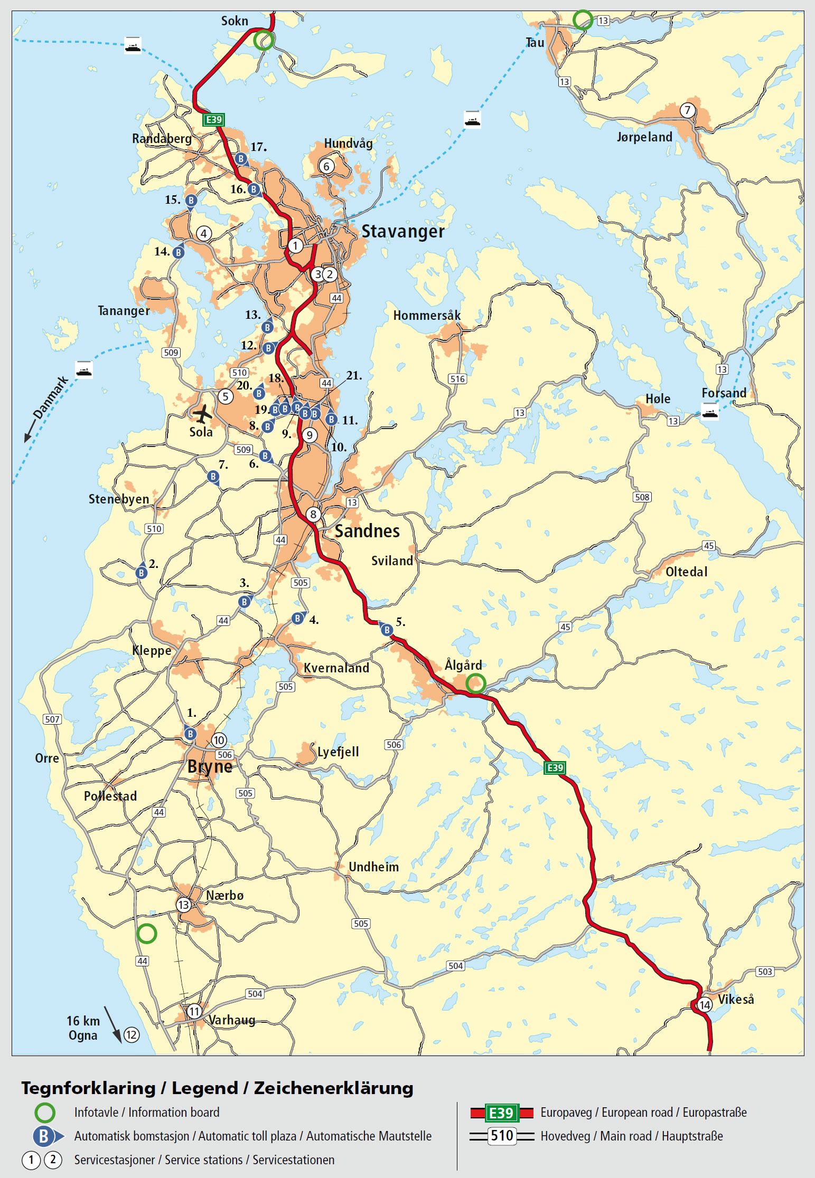

Tollbooth # and Name 1 KÅSEN, 2 SELE, 3 ØKSNEVAD, 4 ORSTAD, 5 BRÅSTEIN, 6 SOMA, 7 ÅRSVOLL, 8 BÆRHEIM, 9 MOTORVEIEN, 10 FORUSVEIEN, 11 GAMLEVEIEN, 12 NESBUVEIEN, 13 GRANNES, 14 HAFRSFJORD, 15 KVERNAVIKVEIEN, 16 RANDABERGVEIEN, 17 FINNESTADGEILEN, 18 SVANHOLMEN, 19A FORUSBEEN, 19B ÅSENVEIEN, 20 TRAVBANEVEIEN

Found Your New Home?

Before Signing the Contract
“Renting a Home In Norway” is a leaflet from the legal office. Please read through this and any items that are unclear can be discussed with the legal office (+ 47-5195-0532/DSN 224-0532) or CEH (+47-5195-0577 / DSN 224-0577).

When you have found a house of interest, you should send and offer to the realtor in writing and a copy to the housing office. There is a lot of competition with the oil companies also renting houses here, so the turnaround time for properties may be very short. One thing you should consider while based at Jåttå (Joint Warfare Center and the 426th ABS) is the driving distance to and from work. Wherever you choose to rent a property you should not need more then 20-25 minutes to drive to work. If you have children consider the distance to the ISS (International School of Stavanger) and if your house is on, or close to an ISS bus route. As we have a very small base here, you will find most activities, sports and leisure etc. will be situated in the local community so there will be a lot of extra driving, especially if you only have one vehicle.

A standard copy of a rental lease is available from CEH; if however you decide to use a Realtors contract there are certain conditions, which must be included:

1) The Military clause must be included in case you PCS out early. It is standard to have a 30-day clause, but some property owners have asked for 60 days, this usually is acceptable.

2) Due to the high activities in this area, there is not much to negotiate with your landlord, the landlords will easy get the asking price for the property and therefore not room to include any extra items in the lease i.e. installation of Cable TV, Internet, inclusion of wood delivery for heating. Please be advised that although verbal agreements are legal, we advise that any agreement be in writing and signed by both parties. A two months security deposit may be required.

3) If you are bringing in a pet or are planning to get one, you need to have it in your lease that you are allowed to have a pet in the house. Landlords may ask for a deposit of at least two month’s rent. If you require financial help, please contact the Finance Office at 51950539. The deposit should be put in an interest collecting account in your name.

Try to take procession of the home as early as possible in the morning so as to coincide with the delivery schedule of appliances and loaner furniture for use until your household goods arrive.

After Signing the Contract
Please let CEH have 2 copy of the lease, 2 copies of orders and your final hotel bill, a completed USAFE FORM 333, and then we can process the OHA. Again I will stress: check the information thoroughly before signing. If on your house lease there are any extra items /conditions to be included write them on the lease on both copies. I cannot express enough the importance of this!!

Moving In

Housecleaning
The Norwegians always clean a house before people move in. Unless you move in at an earlier date, the house should be spotless. When you move out they will expect the house to be left in the same condition (minus wear and tear). If you require cleaning help it is a good idea to hire a cleaning agency. These can be found in the local telephone directory under Rengjøringstjenester (cleaning firm) or online at www.gulesider.no (use the English tab). They are experts; charge reasonable prices and do an excellent job.

Trash Pick Up
When you find a house either in Stavanger, Sandnes, Sola or Randaberg kommunes you can call the following numbers to get the collecting schedule for your trash. Have your address handy when you make your call, most customer representatives speak English.
Stavanger call 5150-7000 press 1
Sandnes, call 5197-6000
Sola, call 5165-3300
Randaberg, call 5141-4100

Loaner Kits Request
PLEASE REMEMBER TO INCLUDE ALL THE ITEMS YOU NEED AS WE TRY TO MAKE ONLY 1 DELIVERY AND 1 PICKUP ON MOVING IN AND AGAIN UPON MOVING OUT. TEMPORARY ITEMS ARE AVAILABLE ON LOAN FOR 30 DAYS.

REQUEST FOR(name, address, phone#, date of delivery): _______________________________________________________________________________________

DURATION OF TOUR ITEMS Available _____ ____________ Order

REFRIDGERATOR 1
WASHER 1
DRYER 1
FREEZER 1
TRANSFORMERS (1000 or 2000 watts, subject to availability) 2 per accompanied 1 per unaccompanied
MICROWAVE 1 if available
OIL FILLED RADIATOR HEATER 200W 1

The Housing Office will not provide appliances if the landlord provides these items to your residence. Exemption may be given on a case-by-case basis, and must be approved by the CC or his designated representative.

30-DAY LOANER KIT ITEMS

Dining Room
Chairs, dining 4
Table, dining 1
High chair 1

Living Room
Table, coffee 1
Table, end 1
Sofa 3+2 1
Lamp, floor 1
Lamp, desk 1
Lamp, small 1 per night stand

Bedroom
Bed, single 1 per family member
Crib 1 per infant
Chest, four drawer 2 per family
Night stands 2 per family

MISC ITEMS (very limited, only a few sets available).
44 Piece Tableware kit Plates, Cups, Flatware
50 Piece Kitchen set Items Below:
Kitchen Utensils and dishes to include: cutting boards, plastic food storage set, frying pan, pot w/lid, serving dishes, can opener, garlic press, cooking spoons, hot pads, grater, knife set, measuring cups, mixing bowls, peeler, mug, scissors, spaghetti fork, spatulas, strainer, timer, whisk, and wine opener. It is mandatory to do an inventory before turn in .

ATTN! NB!!!! Please give housing at least one-week notice, of when you require delivery or pickup of loaner kits. Deliveries are made preferably Thursday 08.00 -12.00 during the summer time. Please be available to sign for these items. One contractor delivery/pickup is available to members when moving in and another again upon moving out.
I __________________________________ understand that I am subject to disciplinary action under the UCMJ or appropriate civilian personnel regulations should I not be at my quarters during the period scheduled for this appointment unless I have previously notified CEH in time for them to reschedule the appointment. In addition, I ____________________________understand I may be held financially liable for the cost the government incurs as a result of the missed appointment or any requested items return on the delivery date. Items returned are requested to be in a condition that you would like to have them.
MEMBERS ARE RESPONSIBLE FOR THE CARE AND NORMAL UPKEEP OF ALL FURNISHINGS AND APPLIANCES ISSUED TO THEM AND WILL BE HELD FINANCIALLY LIABLE FOR LOSS OR DAMAGE WHICH OCCURS THROUGH NEGLECT OR IMPROPER USE. (DoD 7200.11, Liability for Government Property Lost, Damaged or Destroyed and AFMAN 23-2200 Reports of Survey for Air Force Property Para 1.4.2/3)

Size of Loaner Appliances
 | Portable heaters
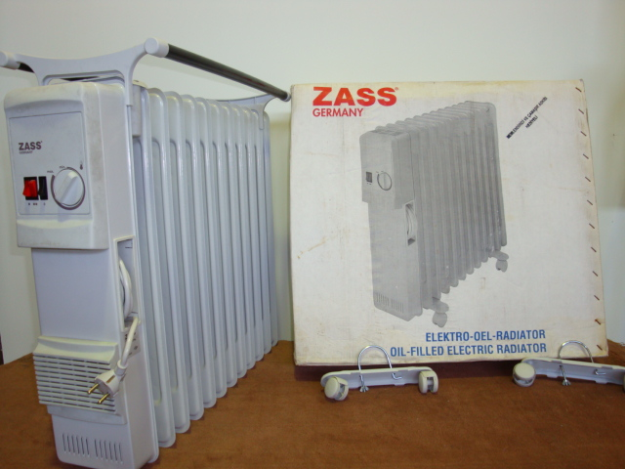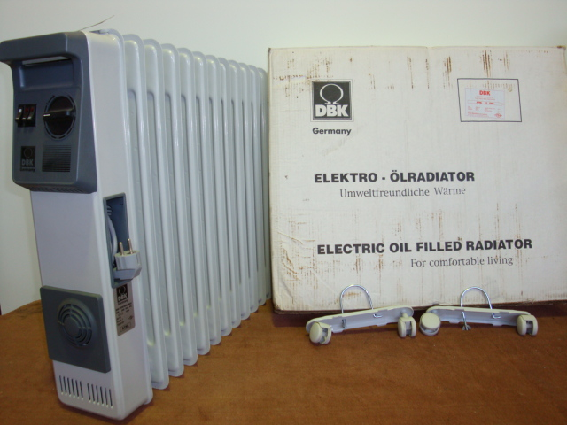 | 230V 2000W
Electric Oil Filled Radiator
 | Size overall |  |  | Inside size: fridge
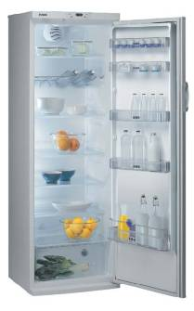 | height | Length | width | Height | length |  | width
Fridge | 62.60” | 23.62” | 23.62” | 55.91” |  | 17.72” |  | 20.87”
 | Size overall |  |  | Size inside freezer |  |  |  |  | Size inside quick freezer
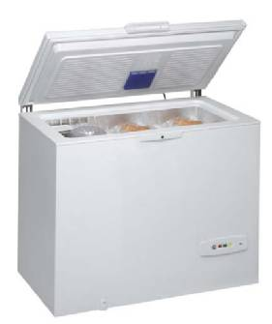 | height | Length | width | Height |  | length |  | width | height | length | width
Freezer – 265 Liter | 35.43” | 27.56” | 35.58” | 29.13” |  | 18.90” |  | 23.23” | 18.90” | 18.90” | 9.84”
 | Size overall |  |  | Size inside
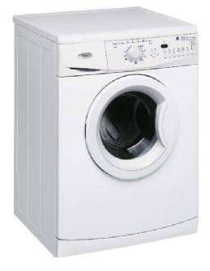 | height | Length | width
Washer | 32.68” | 23.62” | 23.62” | Door Ø=11", 12.13 lbs 48 ltr
 | Size overall |  |  | Size inside
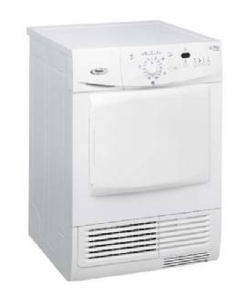 | height | Length | width
Dryer | 32.68” | 23.62” | 23.62” | Door 15.3x11.42", 13.23 lbs
 | Size overall |  |  | Size inside
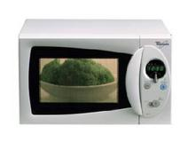 | height | length | width | Height |  | length |  | width | Volume inside 18 ltr.
Microwave 750 W | 13.11” | 17.64” | 20.79” | 11.22” |  | 15.19” |  | 17.95” | Dish Ø=10.7"

Loaner Kit Extension

I ………………………..................................... verify that I have been granted a loaner kit extension to extend from 30 days to the length of my tour, with the understanding that if at any given time the loaner kit is required, it will be turned into the housing office within 24 hours, and that these items must be returned in a clean condition. Any loss/ damage to these items must be reported to CEH on an USAFE Form 432, Loss and/or damage of Government Owned Furnishings Report immediately, and payment will be required to cover this cost (less respective wear & tear). I have read this statement and accept and fully understand these conditions.
The items I have in my possession are as listed below:

1)........................................................ 2)........................................................

3)........................................................ 4)........................................................

5)........................................................ 6)........................................................

7)........................................................ 8)........................................................

9)........................................................ 10)......................................................

Member’s signature............................................................................

Housing Officer.................................................................................

Date...................................

Landlord (Agent) Certificate

Substitute USAFE Form 113 Part I - Concerning Government-Owned Furnishings

TO WHOM IT MAY CONCERN
The tenant agrees to pay all charges against U.S. Government property issued to him/her. The landlord/agent agrees that all U.S. Government issued furniture/ supplies (sofa, beds, dressers, dining table, chairs etc.) will not be held in lieu of any debts incurred by the tenant. Further, in case of emergency, the landlord/agent agrees to permit a Government representative to enter the premises and remove such U.S. Government property.

...................................................................................................................................................................

ERKLÆING OM EIENDOMSRETT I UTLÅN AV US-EID UTSTYR

TIL DEN DET MÅTTE ANGÅ
Leietaker er ansvarlig for all utgifter som påløper som det utstyr nevnt (sofa, stoler, bord, senger, kommoder osv) I denne erklæring, varer som eies av den amerikanske stat og er utlånt til leietaker. Utleier godtar at det utstyr listet I denne avtale ikke kan benyttes som sikkerhet eller til dekning av utestående fordringer mot leietaker. Videre, I nødstilfelle, gir utleier tillatelse til at representant for den amerikanske stat blir gitt adgang til utleieobjektet for å hente det utstyr nevn I denne avtale.

___________________________________ Tenant PRINTED Name (Last, First, MI)
Leiertaker’s navn

____________________________________ Local Address/address

____________________________________

____________________________________ _________________
Tenant /Leietaker’s Signature Dato

Utleier /repr. Navn m/ blokkbokstaver _____________________________________

Utleier /repr. Signatur _____________________________________ Dato ________________

Substitute USAFE Form 113

Government Appliances and Satellite Dish Authorization

Substitute USAFE Form 113 PART 2

I hereby authorize the installation of the following Government owned appliance(s) (Whirlpool washer, dryer, refrigerator, and deep freezer) at the mentioned address and certify that connections are available for these appliances. (All appliances are Norwegian 220 volts). I also authorize installation of a separate satellite dish for receiving Armed Forces Network (AFN).

I also agree that U.S. Government appliances will not be held in lieu of any debts incurred by the tenant and, in case of emergency, permit a government representative to enter the premises and remove such Government property.

...................................................................................................................................................................

US HVITE VARER

Jeg gir herved tillatelse til instalasjon av følgende utstyr, (Wirpool Vaskemaskin, tørketrommel, kjøleskap og Gram fryseboks) varer som eies av den amerikanske stat, på overnevnte adresse. Videre bekrefter jeg at det er tilkoblingmuligheter for det utstyr listet I denne avtale (alt utstyr er beregnet for 220v). Jeg gir også tillatelse til å innstallere en egen Parabol antenne for å motta Armed Forces Network (AFN).

Jeg godtar at utstyr av den amerikanske stat ikke kan benyttes som sikkerhet eller til dekning av utestående fordringer mot leietaker. Videre, I nødstilfelle, gir jeg tillatelse til at representant for den amerikanske stat blir gitt adgang til utleieobjektet for å hente utstyr nevnt I denne avtale og som eies av den amerikanske stat.

Utleier/ repr. Navn m/blokkstaver _____________________________________

Utleier/repr Signatur ______________________________________

Dato/Date ______________________________________

Tenant’s Name/Leietaker’s Navn ____________________________________________

Address/Adresse _____________________________________________

Substitute USAFE Form 113

Care of Appliances

Dear Customer

Please help us look after the Government-owned appliances you were issued. They are a valuable asset. Please retain all instruction booklets and manuals so they can accompany the appliance when it is turned in. Upon turn-in all faults or problems should be reported. All appliances should be disconnected before pick-up by 426 ABS personnel. All appliances must be easily accessible for pick-up. All cleaning and defrosting must be completed before pick-up, as a return trip will be charged directly to you. Plan ahead when turning in appliances. Make sure you have all required cleaning materials. The following should help you to understand our standards and meet them:

REFRIGERATOR: Will be cleaned on interior and exterior, removing stains, food particles, grease etc. If the freezer section requires defrosting, do not use sharp instruments to remove the ice. The interior walls are easily punctured, and some of the punctures cannot be repaired. Damages will be charged customers against negligent. Plan ahead, cleaning and defrosting can take up to 4-5 hours or longer. When cleaned, polish exterior and interior with a soft cloth, for a streak free finish. Do not close refrigerator once cleaned, as this can cause an unpleasant odor. Block the door open at least one inch to allow the air to circulate.

WASHER: To be cleaned on exterior and interior. All removable parts, should be removed, cleaned, and replaced. Soap dispenser should be free of all residues. All water should be removed. In the front at the bottom of the washer there is a tap that you twist to
get out the remaining water. The drum and agitator shall be free of water spots and soap film. Wipe interior dry with a clean cloth. Wipe exterior with a soft cloth.

DRYER: To be cleaned on interior and exterior. The drum should be cleaned following the manufactures recommended procedures. The lint filter should have all lint removed, and be cleaned. The drawer that contains the condensation water should be empty. After cleaning, dry with a soft cloth.

Basically this will not be a white glove inspection, but we do expect the appliances to be picked up in a condition, that you yourselves would be happy to receive them.

MEMBERS ARE RESPONSIBLE FOR THE CARE AND NORMAL UPKEEP OF ALL FURNISHINGS AND APPLIANCES ISSUED TO THEM AND WILL BE HELD FINANCIALLY LIABLE FOR LOSS OR DAMAGE WHICH OCCURS THROUGH NEGLECT OR IMPROPER USE. (DoD 7200.11, Liability for Government Property Lost, Damaged or Destroyed and AFMAN 23-2200 Reports of Survey for Air Force Property Para 1.4.2/3)

Thank you
426 ABS/ Housing Referral Office

Care and Maintenance of Furniture

THE FOLLOWING HINTS ARE INTENDED TO BE HELPFUL IN THE CARE AND MAINTENANCE OF FURNITURE.

1. TREATMENT OF SPOTS, STAINS AND SCRATCHES ON WOODEN PARTS.

a) WATER SPOTS : Apply heat and moisture by placing a warm iron over a damp blotter. Use brief application and repeat until the spot has disappeared.

b) ALCOHOL SPOTS : Rub area with finger dipped in wax, silver polish, boiled linseed oil, or with a slightly damp cloth with ammonia.

c) INK STAINS : Clean with cream wax or with damp cloth (DO NOT RUB) These stains, stains cannot be removed if they have penetrated the wood.

d) HEAT MARKS : On varnish or shellac finish, a dampened cloth with turpentine will remove white heat marks.

e) MILK STAINS : Clean with a cream wax and repolish the wood. To hide the stain, use the same as recommended under “alcohol spots”

2. REMOVAL OF SPOTS FROM UPHOLSTERY

a) CANDY : Sponge with clean water.

b) GUM : Rub lightly with an ice cube then scrape or rub until the gum is removed.

c) COCKTAILS : Sponge at once with a cloth dampened in mild soapsuds and rinse with a clean cloth

d) COFFEE/TEA : Follow procedures for “cocktails” if this does not work, try steaming.

e) INK : Blot the soiled area then sponge with lukewarm water or milk. If the
stains remain; make a solution of one part denatured alcohol and two
parts water and sponge again.

f) LIPSTICK : Sponge with diluted alcohol (2-water/1 alcohol)

ATTN! NB! CLEAN SPOTS IMMEDIATELY, THEY ARE EASIER TO DEAL WITH FRESH!

Security Deposit

The landlord-tenant law allows for a tenant deposit up to a total of six months rent including any advance payment of rent. The security deposit will cover any claim arising out of this lease, unless the two parties have agreed to limit the scope of the security deposit.

The most common reasons for the landlord to claim payment from the security deposit are:

Lacking rent payment
Improper cleaning of the lease object

Damage to the lease object or inventory

Since the maximum security deposit is based on a total of six months rent, for your convenience, we recommend that the lease agreement should state: “Security deposit will not be adjusted if the agreed rent is adjusted upwards”.

The common security deposit is deposited into a special bank account. The tenant establishes the account and it is only valid when the landlord has put his signature on the bank provided document. The amount deposited cannot be controlled by any of the parties unilaterally during the lease. The interest earned on the amount belongs to the tenant and is under the tenant’s control (for example, withdrawal of the interest amount).

After termination, both parties can demand to take control over the funds. If the tenant demands control over the funds and has obtained the landlord’s approval in writing, the bank is obligated to pay out the amount to the tenant. If the landlord’s signature is missing on a tenant’s request, the bank that holds the deposit will notify the landlord and give the landlord one month to object to the claim. The landlord will have to prove that the landlord has taken legal action against the tenant. Receipt of such documentation legally requires the bank to keep the security deposit until the situation has been finally settled (judgment or other proof of settlement). If the landlord fails to provide such documentation within the time allotted, the bank is obligated to release the funds to the tenant.

Ask your bank for detailed information!

APPROVAL OF HAND OVER/RELEASE OF SECURITY DEPOSIT ACCOUNT

The security deposit in the amount of NOK _____________ in account number ______________________

with (name of bank) _________________________________ can be released to (Name of

tenant)__________________________________, tenant, concerning the security account established concerning the

lease object located at (address)______________________.

I have received possession of the described lease object in a timely manner and have accepted the lease object’s condition.

By my signature below, I hereby approve release of the above described security account, I have no known claim against the tenant or the lease object.

Place and date: _________________________________________

Landlord

Name: _______________________________________________

Signature: _____________________________________________

 | DEPARTMENT OF THE AIR FORCE

MEMORANDUM FOR WHOM IT MAY CONCERN

FROM: 426th ABS/CEH
Unit 6615
APO AE 09706

SUBJECT: Advance for Security Deposit

Security deposit. Your landlord may ask for a 1-3 months rent security deposit. Deposit this money in a special security deposit bank account. The account will be in your name and the interest will be yours. However, you will need the landlord’s concurrence to take money out of the account. When you move out of the house, the security deposit is meant to cover damages and poor cleaning. The remainder of the security deposit must be released to you within 60 days after the lease is terminated, unless there is a continuing dispute. Contact FMF for a possible advance to cover the deposit.

Name: SSN#:

Permanent Duty Station: _______________________________ Order Number______________

Moving in Date: _________________ _______ Duty Phone# _______________

IAW the lease agreement dated_____________ the landlord requests __________month/s

Security deposit for his property at__________________________________________________

___________________________________________________Norway, for NOK____________.

“I CERTIFY THIS INFORMATION IS TRUE AND CORRECT.”

Members signature: _____________________________________________ Date: __________

I certify landlord is requesting _________month/s security deposit IAW lease agreement

between (member) __________________________________________ and

(Landlord) ____________________________________________________

and I confirm the moving in date is_________________________________.

426 ABS/CEH Signature: ________________________________________ Date: __________

WILLIAM KOLNES, CIV, USAF
Housing Management Assistant, 426 Air Base Squadron

Useful Websites
426 ABS http://www.426stavanger.com/

Individual Overseas Housing Allowance (OHA) Location Code NO021, http://www.defensetravel.dod.mil/site/ohaCalc.cfm

EM-1 Boligleie Utleiemegleren
http://www.boligutleie-stavanger.no http://www.utleiemegleren.no
Kvitsøygt. 15, 3rd floor Østervågkaien 21
4014 Stavanger 4013 Stavanger
mail: boligleie@em1.no Mail: stavanger@utleiemegleren.no
Phone +47 51 95 90 30 Ph: + 47 51501120

Local Newspapers
The local newspaper: http://www.Stavanger-aftenblad.no/
Norway Post http://www.norwaypost.no

Local Community Sites

The county: http://www.rogfk.no
The Norwegian Government: http://www.norway.no/Default.asp?
The Norwegian Government in US: http://www.norway.org/
The Stavanger Convention Bureau: http://www.regionstavanger.com/
Stavanger WEB: http://www.stavanger-web.com
INN – International Network of Norway
Stavanger Map Guide http://www.stavanger-guide.no
Stavanger Clickwalk http://stavanger.clickwalk.no/indexe.html
Current Time in Stavanger http://www.timeanddate.com/worldclock/city.html?n=289
Stavanger Weather http://weather.yahoo.com/forecast/NOXX0035.html

GENERAL MAINTENANCE LIST

Ventilation
Due to our Nordic climate, Norwegian houses are well constructed and mostly wooden. This means that the houses can be air tight if not continuously ventilated. It is therefore of utmost importance that vents are kept open in bedrooms and bathrooms in order to prevent dampness and mold. This also contributes to a healthier indoor climate.
Please ventilate especially during cooking and clothes drying.

Windows
Always close sky lights when leaving the residence, due to Norway’s unstable weather conditions.

Wooden floors
Norwegian homes have mainly wooden floors and they need to be maintained correctly.
Regular maintenance requires sweeping with a soft bristle broom, and vacuuming with a soft floor attachment.
Do not wet-mop a wooden floor!!
Liquid left on a wooden floor can dull the finish, damage the wood and leave a discolouring residue. Wipe up spills immediately with a slightly dampened cloth.
Use felt/rubber pads under the legs of furniture to prevent scuffing and scratching.
It is not common to use shoes on parquet flooring, specially high heels.

Electrical equipment
Remember, never to leave the residence with electrical equipment plugged in!

Interior
Pictures etc.
Putting tacks/nails into walls, doors and windows is prohibited unless agreed with the Lessor. Pictures etc. must be hung using thin tacks. Any marks made on interior during your tenancy, must be fixed upon leaving the property.

GENERAL CLEANING

Kitchen
Clean the kitchen fan/filter and hood monthly. When greasy, the filter is in danger of catching fire. The filter can in most cases be put in the dishwasher for cleaning.

Clean cooker/hotplates and oven after every use. Check whether the oven has self-cleaner installed, if so, make sure to use it on a regular basis.

Bathroom / laundry room
Check and clear drains to prevent flooding. Use only MUDIN Avløpsåpner. Can be bought at most hardware stores and bathroom suppliers. Please use minimum twice a year.
Clean the filter in tumble dryer after each cycle, to prevent fire.

IMPORTANT CHECK POINTS

Monthly checkpoints
- Dust / clean heaters and any radiators.
- Clean light switches/mirrors/lamps to remove hand-/fingerprints etc.
- Clean any spills in fridge.
- Rinse outdoor garbage/dustbins.

Annual checkpoints
- Check / change the batteries in smoke detectors, normally December 1st.
- Check / clean all drains, i.e. kitchen-/laundry, sink, showers and underneath bath tub.
- Check status and date on the fire distinguisher by turning it upside down.
- Wash windows inside and outside – (preferably a couple of times a year)
- Defrost freezer, clean thoroughly.
- Turn and hoover matresses, wash cover of over matress if possible.
- Curtains – wash (if possible) with suitable cleaning product (machine/handwash).
- Carpets – check for stains, clean if needed.
- Gutters – check for overspill of rainwater and notify owner if needing attention
- Snow – clear driveways and pavement if applicable.

GARDEN

Mow the lawn regularly/when needed and when the grass is dry. Rake up any leaves and grass. Keep the flower beds and drive way neat and tidy, remove weeds.

NB!
Lessor is responsible for cutting hedges, bushes and trees - unless agreed otherwise.

To keep the property in a clean and orderly manner is the best way to avoid arguments and disputes upon leaving.

Good luck with your tenancy and your new home ☺

RECEIVED: Date……………..

SIGNATURE:………………………………………

COMMONLY USED TERMS ON PROPERTY WEBSITES
Another website that you may consider visiting is http://www.finn.no/. This site has sections for all types of items for sale or lease, from tractors, boats, cars, etc to houses. Although this site is in Norwegian only, we've listed some common translations of real estate terms below. To look for housing, firstly click http://www.finn.no/eiendom/ . This will allow you to enter the residential accommodation portion. Then click http://www.finn.no/finn/realestate/lettings/browse1 ( or the Leiemarkedet ( lease market) sub-site). Then choose Rogaland and then the municipality that you wish to look at.
Note that refundable security deposits are required at the commencement of leases and that they could be anywhweres from 1/2 to 2 months rent. Generally, you are responsible for any furniture or appliances that the landlords leave, and for electricity or natural gas use, for telephone, internet and cable or satellite TV costs. You may also be responsible for exterior cleanliness including gardening.
Norwegian | English
annonserer | advertisement
alle | all
barnevennlig | child-friendly
bolig | residential
boligareal | size of house ( in sq meters)
bydel | part/area of town
dusj | shower
eiendom | property
eiendomstype | type of property
enebolig | single home
e-post adresse | email address
etasje | floor/level
gang | hall(way)
garasje | garage
hjelp | help
kontakt (oss) | contact us
kar | bathtub
kart | map
kjelleren | basement/cellar
kjop | buy
kjope bolig | buy a property
kommune | district
leieperiode | lease period
leielighet | flat/apartment
linker | links ( to other sites)
loftstue | living room in attic/ upper level
megler | estate agent
navn | name
omrade | area
oversikt | overview
peis/ildsted | fireplace
post til oss | email us
poststed | post code
pris (fra) (til) | price (from) (to)
rekkehus | terrace house
salg | sale
sok | search
sok etter bolig/eiendom | search for a property
soverom | bedroom
til leie | to lease
til salg/ for salg | to sell / for sale
tlf dag/kveld | telephone day/evening
tomt | land for sale
(u)moblert | (un)furnished
utgang | exit
vaskerom | laundry room
velg | choose
vertikaldelt bolig | semi-detached/townhouse
vis (boliger) | show (properties)

GOOD LUCK IN YOUR NEW HOME

We do hope that you will enjoy your new home. Norway is a beautiful country, and you should use your time here to explore the wonderful countryside, the mountains and fjords,
and all the while we hope you enjoy your time in Norw

The 426th Housing Office

Receiving receipt for housing package

I ………………………..................................... verify that I have received and briefed in the Moving in Housing information by the housing office; I also understand my responsibility to actively seek housing as listed on page 5:
Within the first 10 days, the service member should view a minimum of two houses. During the subsequent 10-day increments, the service member should view at least additional five listings. If permanent housing has not been secured, necessitating a third 10-day increment, the service member must meet with a Housing Management Specialist or Housing Manager to justify additional TLA claims.

Personal preference issues such as pets, furniture limitation, school district etc. are not justification for an extension beyond 30 days. Under normal circumstances, TLA extension will not be allowed when referral listings are available within service member’s bedroom entitlement, Overseas Housing allowance (OHA) ceiling, and commuting distance as determined by the Housing Manager.

Additionally I understand that any communication/negotiations between myself and the realtor agent/landlord should be conducted via email and include a courtesy copy to the Housing Manager (william.kolnes.no@stavanger.af.mil)

I have read this statement and accept and fully understand these conditions.

Member’s Name (block letters)............................................................................

Member’s signature.............................................................................................

Date...................................

