SALE OF NONAPPROPRIATED FUND PROPERTY

56 FSS/LODGING is Accepting Sealed Bids

Lot # 3: 2010 Ford F-150 w/Tommy Lift Mileage: 43,700

Condition: Fair Minimum Bid: $2,000

Vehicle will be SOLD AS IS No warranties or guarantees given

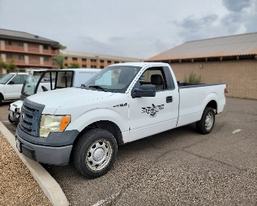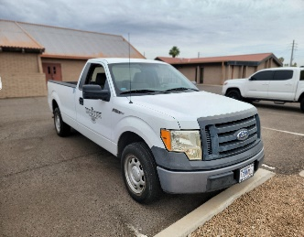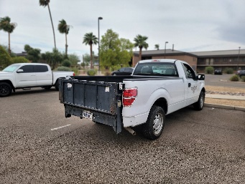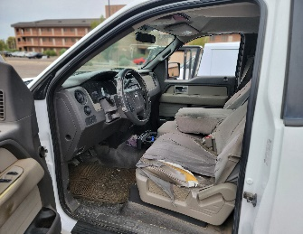

Vehicle can be viewed by appointment Contact: Ms. Bartek, 623-856-6336 or Mr. Burton, 623-856-7437

Bid forms available at Outdoor Recreation or online at 56FSS.com

Mail or hand deliver sealed bids to 56 FSS/FSR, RE: NAF BID 2010 Ford F-150 w/Tommy Lift, 7383 N Litchfield Rd, Ste 3045, Luke AFB, AZ 85309

Deadline for accepting sealed bids: 4:00 P.M., 11 December 2023.

Bid opening will take place on 13 December 2023.

Highest bidder will be notified within 24 hours. In case of tie for high bidder, we will attempt to contact each high bidder to submit another bid.

Payment by cash, credit card, or cashier’s check required no later than 18 December 2023.

All sales are final, and all equipment must be removed from premises by
1:00 P.M., 21 December 2023.

Removal and transport of all items are the sole responsibility of the buyer.

56 FORCE SUPPORT SEALED BID SHEET

NAF EQUIPMENT AND VEHICLES

THE FOLLOWING BID IS OFFERED IN RESPONSE TO A SOLICITATION FOR SEALED BIDS DATED
LOT # 3

ITEM DESCRIPTION
2010 Ford F-150 w/Tommy Lift Mileage: 43,700

AMOUNT OF MY BID:

DATE OF BID:

PRINTED NAME

STREET ADDRESS

CITY, STATE, ZIP CODE

CONTACT INFORMATION:

TELEPHONE (PLEASE INCLUDE AREA CODE)

E-MAIL ADDRESS

I understand that all bids must be received by 56 FSS/FSR NO LATER than 4PM, 11 December 2023.

ALL SALES ARE FINAL

All vehicle is offered in “AS IS” condition, no warranties or guarantees given.
Each item will be sold to the highest bidder and payment must be made by cash, credit card, or cashier’s check before property is released.

Removal and transport are sole responsibilities of the buyer.

_______________________________________________________________________

Signature of Bidder

ALL BIDS MUST BE PLACED IN AN ENVELOPE, SEALED, MARKED AS FOLLOWS, AND MAILED OR HAND-DELIVERED TO:
56 FSS/FSR
RE: NAF VEHICLE BID – 2010 Ford F-150 w/Tommy Lift
7383 N LITCHFIELD RD, SUITE 3045
LUKE AFB, AZ 85309

