**JULY 2023**

**Registration ends 1 day before ALL class dates,**

**Unless noted otherwise.**

**Classes and events are open to all military, civilian personnel and their families with base access. Call 334-953-2353 for information and registration.**

**All classes are held at the Maxwell M&FRC, Bldg. 677, unless noted as follows; (G) Gunter; (V) Virtual, (MC) Maxwell Club**

|  |  |  |  |  |  |
| --- | --- | --- | --- | --- | --- |
| **Monday** | **Tuesday** | **Wednesday** | **Thursday** | **Friday** | **Special Events** |
| **3** |  **| **5**  0900 **(CANCELLED)**  **Pre-Separation Counseling**  1200 **For Deployed Families:**  **5 Financial Skills** | **6**  0800 **Right Start “Orientation**  **for Newcomers” (MC)**  1200 **Key Spouse Initial Training**  1400 **Max-Gun Pre-School Playgroup**  1230-1630 **M&FRC CLOSED** | **7**  0900 **First Duty Station Officer**  1300 **PCS Personal Financial**  **Briefing**  1400 **Promotion Financial Brief**  1500 **TSP Vesting** |  |
| **10**  0800 **TAP Workshop** | **11**  0800 **TAP Workshop**  1200 **Anger Management** | **12**  0800 **TAP Workshop**  1000 **Interviewing Techniques** | **13**  0800 **DOL Employment Track**  1200 **Adult Color Book Session**  1230-1630 **M&FRC CLOSED** | **14**  0800 **DOL Employment Track**  **Financial Friday**  **(Classes on reverse side)** |
| **17** | **18**  1000 **Building Resiliency in**  **Children “Making Stress**  **Work for You”** | **19**  1000 **Resume Writing “Private**  **Sector”** | **20**  0845 **Mx-Gun Pre-School Playgroup**  **(Held at Freedom Park this date)**  1230-1630 **M&FRC CLOSED** | **21**  0900 **Relocation/Sponsorship**  **Awareness Training**  0900 **First Duty Station Officer**  1300 **PCS Personal Financial**  **Briefing**  1400 **Promotion Financial Brief**  1500 **TSP Vesting** |
| **24**  0800 **S-TAP Workshop** | **25**  0800 **S-TAP Workshop**  1000 **Key Spouse Mentor Training** | **26**  0800 **S-TAP Workshop**  0900 **Pre-Separation Counseling**  1000 **Resume Writing “Private**  **Sector”** | **27**  0800 **S-TAP Workshop**  1230-1630 **M&FRC CLOSED** | **28**  **Financial Friday**  **(Classes on reverse side)** |
| **31** |  |  |  |  |

***Maxwell-Gunter Air Force Base***

***Military and Family***

***Readiness Center***

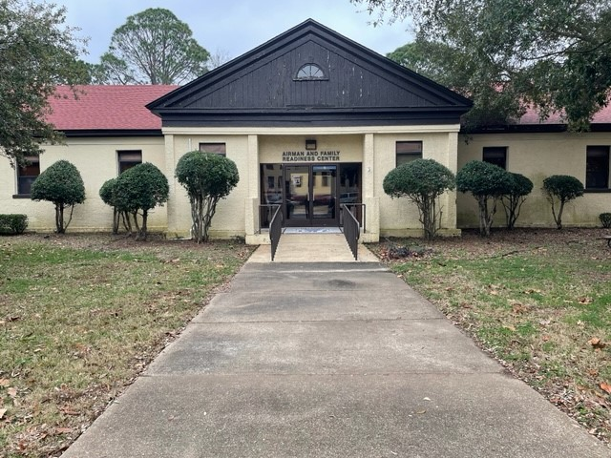

***July 2023***

**Calendar**

* Relocation Assistance
* Volunteer Resources
* Personal Financial Readiness
* Personal and Work Life
* Exceptional Family Member Program
* Personal and Family Readiness (Deployment)
* Employment Assistance
* Transition Assistance Program
* Information & Referral

**Hours of Operation**

Monday-Friday 0730-1630

**Location: Bldg. 677**

55 South Mitchell Street

334-953-2353

[42FSS.FamilySupport@us.af.mil](mailto:42FSS.FamilySupport@us.af.mil)

<https://www.facebook.com/MaxwellGunterMFRC>

**@42MFRC**





**MILITARY & FAMILY READINESS CENTER (M&FRC**): **CLOSED** every Thursday, 1230-1630 for staff training & administrative tasks.

**For Deployed Families – 5 Financial Skills:** 5 July, 1200-1300; “Five Financial Skills to Teach Kids”.

**Pre-Separation Counseling:** 26 July, 0900-1100. 1st (Separatees) and 4th (Retirees) Wednesday of every Month. Second Step in the TAP mandates provide counseling on various benefits, programs, services, tools and other important resource entitlements members may be authorized. (Pre-requisite Initial Counseling /Assessment).

**Maxwell-Gunter Pre-School Playgroup:** 1st (1400-1500) & 3rd (0845-0945) Thursday of the Month; Age 0-5. Enjoy a range of fun activities along with learning about resources available to you, from various participating base agencies.

**Right Start “Orientation for Newcomers”:** (MC)6 July, 0800-1100; This is a one-day orientation for base newcomers opened by the Wing Commander. Right Start is mandatory for military members and DoD civilians. Spouses are cordially invited to attend. Military members must sign up in advance through their CSS or by contacting Ms. Pamela Jackson. Right Start consists of two parts. Part I is held from 0800-1200 at the Maxwell Club, Building 144. Participants have approximately an hour and a half for lunch before Part II begins at 1345. Part II is for active-duty military only.

**Key Spouse Initial Training:** 6 July, 1200-1400; The Key Spouse is a trained volunteer appointed by the Group or Squadron Commander who works closely with the First Sergeant and is directly linked to the Military and Family Readiness Center.

**First Duty Station Officer:** 7 & 21 July, 0900-1130; Personal finance briefing required within 90 days (RegAF) or 120 days (RC) of arrival at first duty station.

**PCS Personal Financial Briefing:** 7 & 21 July, 1300-1400; Personal finance briefing required prior to out–processing, E4/O3 & below.

**Promotion Financial Brief:** 7 & 21 July, 1400-1430; Personal finance brief required 90 days prior to 90 days after date of rank E2-E5/O2-O4.

**TSP Vesting:** 7 & 21 July, 1500-1600; Required of members within 60 days prior and 180 days after 25th month of service.

**TAP 3-Day Workshop:** 10-12 July, 0800-1600; Third Step in the TAP mandates, contains standardized curriculum and deliverables that consist of DoD Day, Department of VA, and Department of Labor to ensure service members meet their respective Career Readiness Standards (CRS). The goal is to prepare service members with the tools necessary to pursue their post-transition career goals. (Pre-requisites Initial Counseling/Assessment and Pre-separation Counseling)

**Anger Management:** 11 July, 1200-1330; This presentation is geared towards adults who need help managing anger. Topics will include defining anger, identifying one’s “anger style,” increasing self-control through personal awareness, practicing techniques to manage one’s own anger, and adopting new strategies to calm other angry people.

**Interviewing Techniques:** 12 July, 1000–1100; This class will help you understand the skills needed to be successful and confident in your next interview.

**DOL 2-Day Employment Track:** 13-14 July, 0800-1600; The Employment Track assists members seeking employment with resume writing, interviewing skills, networking, labor Market information and federal employment. Upon completion of this track, members will have a started a targeted resume. Register NLT a week before the workshop.

**Adult Color Book Session:** 13 July, 1200-1330; Would you like to release your inner colors? Attend this class to enjoy the hands-on experience of creating a wonderful masterpiece while making a connection with others. Attend to build relationships, decrease tension, and improve relaxation.

**Financial Friday:** 14 July, Personal Finance Trainings; Marriage 1230-1300; Divorce, 1315-1345; Disabling Illness/Accident, 1400-1430; Continuation Pay, 1500-1530; Disaster Financial Planning, 1545-1615.

**Building Resiliency in Children “Making Stress Work for You”:** 18 July, 1000-1100; This presentation aims to teach parents how to instill in their children the ability to cope with challenging circumstances, such as the deployment of a parent. Participants will learn how to recognize the characteristics of resilient children; how to form and strengthen bonds with their children; how to build their children’s character; and how to teach their children coping skills.

**Resume Writing “Private Sector”:** 19 & 26 July, 1000-1100; Covers the private sector resume, provides information for inexperienced resume writers & helps you develop the best resume to get that interview.

**Relocation/Sponsorship Awareness Training:** 21 July, 0900-1000; To prepare sponsors to meet the needs of inbound family they are sponsoring.

**Senior TAP 4-Day Workshop:** 24-27 July, 0800-1600; Third Step in the TAP mandates contains standardized curriculum and deliverables that consist of DoD Day, Department of VA, and Department of Labor to ensure service members meet their respective Career Readiness Standards (CRS). The goal of the workshop is to prepare Service members with the tools necessary to pursue their post-transition career goals. (Pre-requisites Initial Counseling/Assessment and Pre-separation Counseling)

**Key Spouse Mentor Training:** 25 July, 1000-1200; The Key Spouse is a trained volunteer appointed by the Group or Squadron Commander who works closely with the First Sergeant and is directly linked to the Military and Family Readiness Center.

**Financial Friday-You Choose the Topic:** 28 July; Goal Setting, Intro to Investing, Protection Planning, Kids & Money, Car Buying, Home Buying, Budgeting and more. You choose the time: 0900-1000, 1030-1130, 1300-1400, 1400-1500 ,1500-1600. Appointment required.